Z170 Touchscreen Computers Datasheet

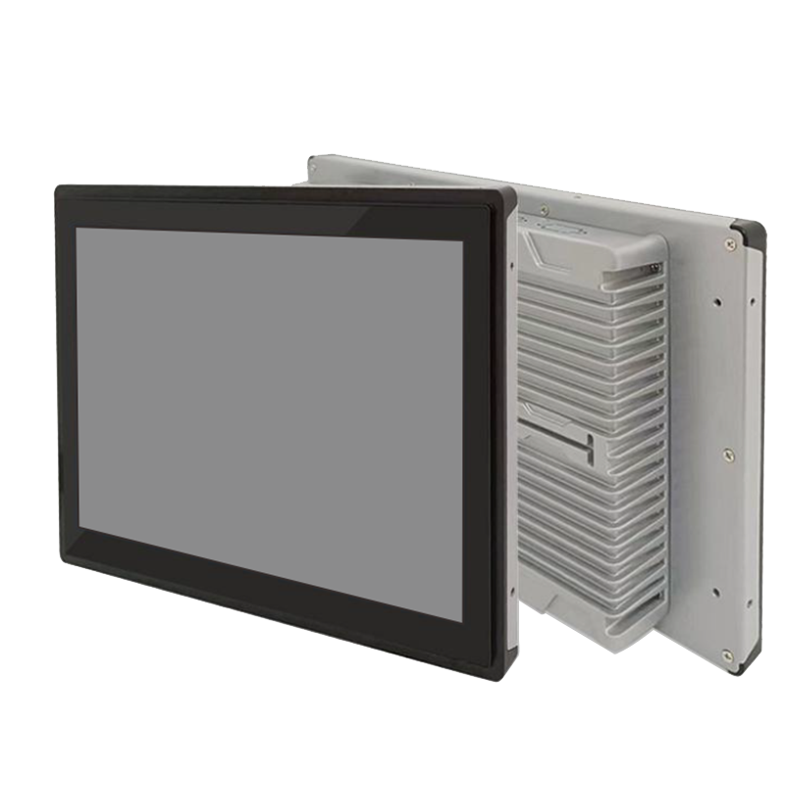
Configurations
● Z170: 17.0" / PCAP Touch / 1280x1024 / Intel CPU/4G RAM/128G SSD/1TB HDD/Windows 10 Pro EN

Features
● Flush mounted
● Water-proof design
● Fanless design

Model | Z170
Chassis | Material / Structure | Fanless aluminum alloy
Chassis | Color | Glossy/Matte/Anode
Chassis | Dimensions (L x W x H) | 356.4mm*221.4mm*55mm
Chassis | Net Weight | 3.0 kg
Chassis | Mounting | Desktop / Embedded flush-mounted
Chipsets | CPU | Integrated Intel (R) Processor, TDP 15W
Chipsets | Graphics | Integrated Intel (R) HD Graphics 620, supports 4K
Chipsets | Memory | 2*DDR4 SODIMM slots, 2133MHz, up to 32GB
Front I/O | Power | 1*Power button, 1*one-key restore, 1*AC loss (power-on boot DIP switch)
Front I/O | LED | 1*Power LED, 1*HDD LED
Front I/O | USB | 3*USB2.0, 1*internal USB2.0
Front I/O | Terminal | 1*12-pin (4 in / 4 out GPIO, switch, 5V)
Front I/O | PS2 | 1*PS/2
Front I/O | SIM | 1*SIM slot
Rear I/O | Display | 1*VGA (1920x1200@60Hz), 1*HDMI1.4 (4096*2304@24Hz)
Rear I/O | LAN | 1*GbE, supports Wake-on-LAN, PXE
Rear I/O | USB | 4*USB3.0
Rear I/O | COM | 2*RS232/485 DB9
Rear I/O | Audio | 1*Line out, 1*MIC
Rear I/O | Power | 1*DC power jack or 1*3-pin terminal, supports 9~36V input
Disk storage | SATA | 1*2.5-inch drive bay
Disk storage | mSATA | 1*mSATA
Expansion | Mini PCIe | 1*Mini PCIe, supports 4G module
Expansion | M.2 | 1*M.2/WiFi, Key-E 2230, WiFi module
OS | Microsoft Windows | Windows 10/11
OS | Linux | Ubuntu
OS | Watchdog | Hardware watchdog reset (256 levels, 0-255 seconds)
Power | Power Type | External power adapter or open-frame power supply
Power | Input Voltage | DC12V single voltage input
Power | Output Power | 60W~180W
Environment | Operating Temperature | 0°C to 50°C
Environment | Storage Temperature | -20°C to 60°C
Environment | Relative Humidity | 5%-95% RH, non-condensing
Environment | Operating Vibration | 0.5g rms / 5-500Hz / random / operating

Z170Ordering Information

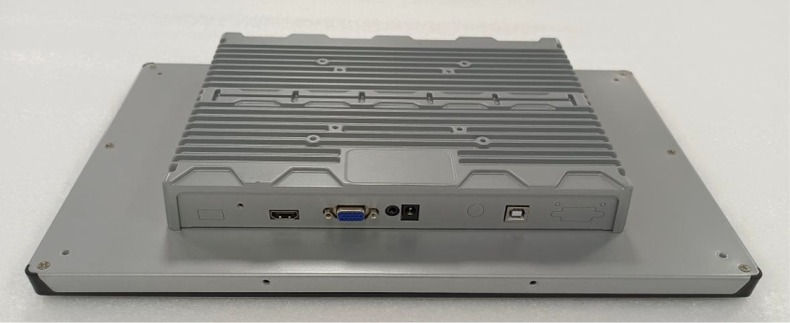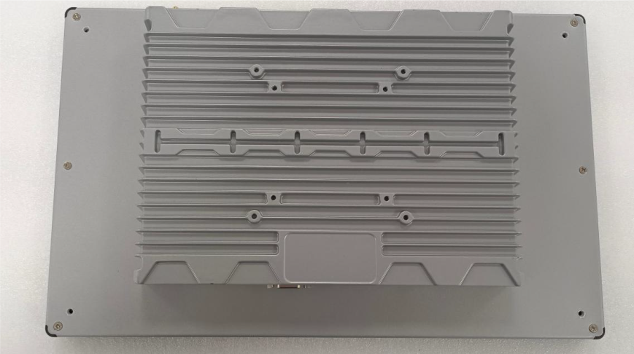
Front view Rear view
Dims：MM
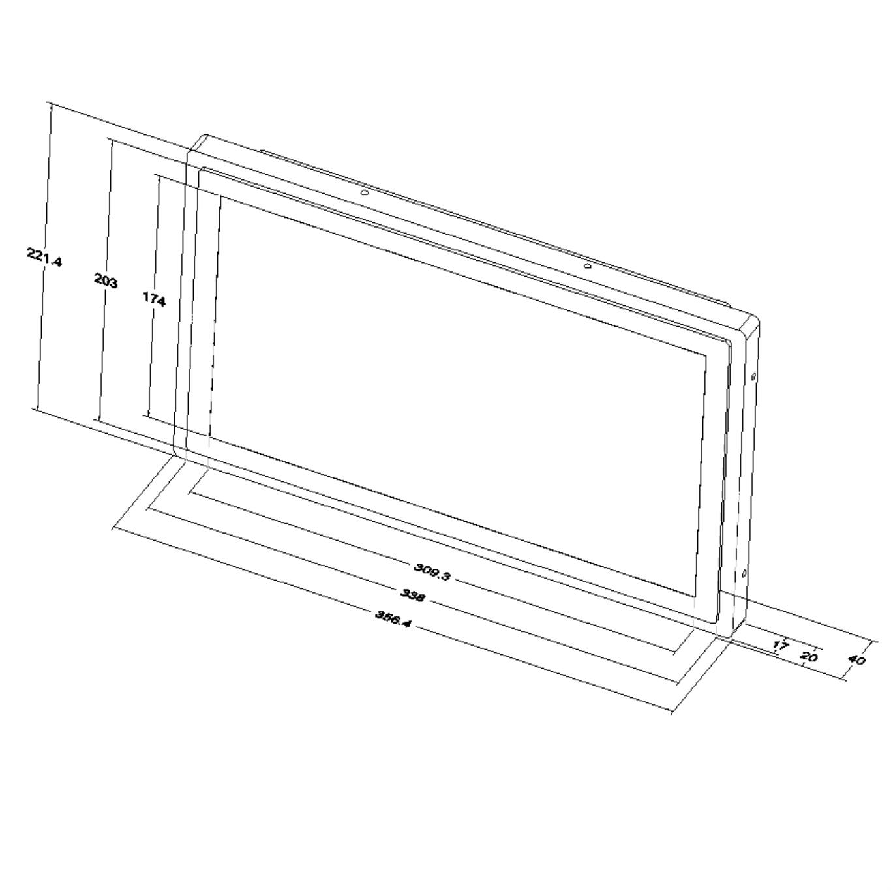

Ordering Information
No. | Model | Technology | Slots Avail. | Configurations | Size | GPIO | WIFI | SIM | LAN | COM | HDMI | VGA | USB | Power
1 | ZA70 | PCAP Touch | 1024*600 | Intel CPU/4G RAM/128G SSD/1TB HDD/Windows 10 Pro EN | 7" | Optional |  |  | 1-2 GbE | 1-2 | 1 | 1 | 4 | DC12V5A
2 | ZA80 | PCAP Touch | 1280*800 | Intel CPU/4G RAM/128G SSD/1TB HDD/Windows 10 Pro EN | 8" | Optional |  |  | 1-2 GbE | 1-2 | 1 | 1 | 4 | DC12V5A
3 | Z101 | PCAP Touch | 1280*800 | Intel CPU/4G RAM/128G SSD/1TB HDD/Windows 10 Pro EN | 10.1" | Optional |  |  | 1-2 GbE | 1-2 | 1 | 1 | 4 | DC12V5A
4 | Z104 | PCAP Touch | 1280x1024 | Intel CPU/4G RAM/128G SSD/1TB HDD/Windows 10 Pro EN | 10.4" | Optional |  |  | 1-2 GbE | 1-2 | 1 | 1 | 4 | DC12V5A
5 | Z116 | PCAP Touch | 1920x1080 | Intel CPU/4G RAM/128G SSD/1TB HDD/Windows 10 Pro EN | 11.6" | Optional |  |  | 1-2 GbE | 1-2 | 1 | 1 | 4 | DC12V5A
6 | Z121 | PCAP Touch | 1280x1024 | Intel CPU/4G RAM/128G SSD/1TB HDD/Windows 10 Pro EN | 12.1" | Optional |  |  | 1-2 GbE | 1-2 | 1 | 1 | 4 | DC12V5A
7 | Z133 | PCAP Touch | 1920x1080 | Intel CPU/4G RAM/128G SSD/1TB HDD/Windows 10 Pro EN | 13.3" | Optional |  |  | 1-2 GbE | 1-2 | 1 | 1 | 4 | DC12V5A
8 | Z140 | PCAP Touch | 1280x1024 | Intel CPU/4G RAM/128G SSD/1TB HDD/Windows 10 Pro EN | 14.0" | Optional |  |  | 1-2 GbE | 1-2 | 1 | 1 | 4 | DC12V5A
9 | Z141 | PCAP Touch | 1920x1080 | Intel CPU/4G RAM/128G SSD/1TB HDD/Windows 10 Pro EN | 14.1" | Optional |  |  | 1-2 GbE | 1-2 | 1 | 1 | 4 | DC12V5A
10 | Z150 | PCAP Touch | 1280x1024 | Intel CPU/4G RAM/128G SSD/1TB HDD/Windows 10 Pro EN | 15.0" | Optional |  |  | 1-2 GbE | 1-2 | 1 | 1 | 4 | DC12V5A
11 | Z156 | PCAP Touch | 1920x1080 | Intel CPU/4G RAM/128G SSD/1TB HDD/Windows 10 Pro EN | 15.6" | Optional |  |  | 1-2 GbE | 1-2 | 1 | 1 | 4 | DC12V5A
12 | Z170 | PCAP Touch | 1280x1024 | Intel CPU/4G RAM/128G SSD/1TB HDD/Windows 10 Pro EN | 17.0" | Optional |  |  | 1-2 GbE | 1-2 | 1 | 1 | 4 | DC12V5A
13 | Z173 | PCAP Touch | 1920x1080 | Intel CPU/4G RAM/128G SSD/1TB HDD/Windows 10 Pro EN | 17.3" | Optional |  |  | 1-2 GbE | 1-2 | 1 | 1 | 4 | DC12V5A
14 | Z185 | PCAP Touch | 1920x1080 | Intel CPU/4G RAM/128G SSD/1TB HDD/Windows 10 Pro EN | 18.5" | Optional |  |  | 1-2 GbE | 1-2 | 1 | 1 | 4 | DC12V5A
15 | Z190 | PCAP Touch | 1280x1024 | Intel CPU/4G RAM/128G SSD/1TB HDD/Windows 10 Pro EN | 19.0" | Optional |  |  | 1-2 GbE | 1-2 | 1 | 1 | 4 | DC12V5A
16 | Z191 | PCAP Touch | 1920x1080 | Intel CPU/4G RAM/128G SSD/1TB HDD/Windows 10 Pro EN | 19.1" | Optional |  |  | 1-2 GbE | 1-2 | 1 | 1 | 4 | DC12V5A
17 | Z215 | PCAP Touch | 1920x1080 | Intel CPU/4G RAM/128G SSD/1TB HDD/Windows 10 Pro EN | 21.5" | Optional |  |  | 1-2 GbE | 1-2 | 1 | 1 | 4 | DC12V5A
18 | Z236 | PCAP Touch | 1920x1080 | Intel CPU/4G RAM/128G SSD/1TB HDD/Windows 10 Pro EN | 23.6" | Optional |  |  | 1-2 GbE | 1-2 | 1 | 1 | 4 | DC12V7A
19 | Z238 | PCAP Touch | 1920x1080 | Intel CPU/4G RAM/128G SSD/1TB HDD/Windows 10 Pro EN | 23.8" | Optional |  |  | 1-2 GbE | 1-2 | 1 | 1 | 4 | DC12V7A
20 | Z270 | PCAP Touch | 1920x1080 | Intel CPU/4G RAM/128G SSD/1TB HDD/Windows 10 Pro EN | 27.0" | Optional |  |  | 1-2 GbE | 1-2 | 1 | 1 | 4 | DC12V7A
21 | Z315 | PCAP Touch | 1920x1080 | Intel CPU/4G RAM/128G SSD/1TB HDD/Windows 10 Pro EN | 31.5" | Optional |  |  | 1-2 GbE | 1-2 | 1 | 1 | 4 | AC100-240V2A
22 | Z430 | PCAP Touch | 1920x1080 | Intel CPU/4G RAM/128G SSD/1TB HDD/Windows 10 Pro EN | 43.0" | Optional |  |  | 1-2 GbE | 1-2 | 1 | 1 | 4 | AC100-240V2A
23 | Z490 | PCAP Touch | 1920x1080 | Intel CPU/4G RAM/128G SSD/1TB HDD/Windows 10 Pro EN | 49.0" | Optional |  |  | 1-2 GbE | 1-2 | 1 | 1 | 4 | AC100-240V2A
24 | Z550 | PCAP Touch | 1920x1080 | Intel CPU/4G RAM/128G SSD/1TB HDD/Windows 10 Pro EN | 55.0" | Optional |  |  | 1-2 | 1-2 | 1 | 1 | 4 | AC100-240V2A
25 | Z650 | PCAP Touch | 1920x1080 | Intel CPU/4G RAM/128G SSD/1TB HDD/Windows 10 Pro EN | 65.0" | Optional |  |  | 1-2 | 1-2 | 1 | 1 | 4 | AC100-240V2A
Notes:
Packinglist
A) 12V5A AC-to-DC Power Supply(Input range: AC100-240V 50/60Hz ) and AC cable for power supply;
B) Warranty card;
C) 1.8M USB TYPE A-to-B cable, HDMI 1.4 cable;
D) (optional)WIFI extension cable and antenna;
E) (optional)VESA-brackets or Two/Four standard L-brackets(optional)
F) (optional)WINDOWS CD driver for motherboard

